Summary on Analysis of Drivers Accepting Bar Coupons

1. Introduction
This report analyzes the behavioral patterns of drivers who accepted bar-related coupons. The objective is to identify key factors influencing coupon acceptance, including demographic characteristics, environmental conditions, and behavioral habits.

2. Data Observations and Analysis

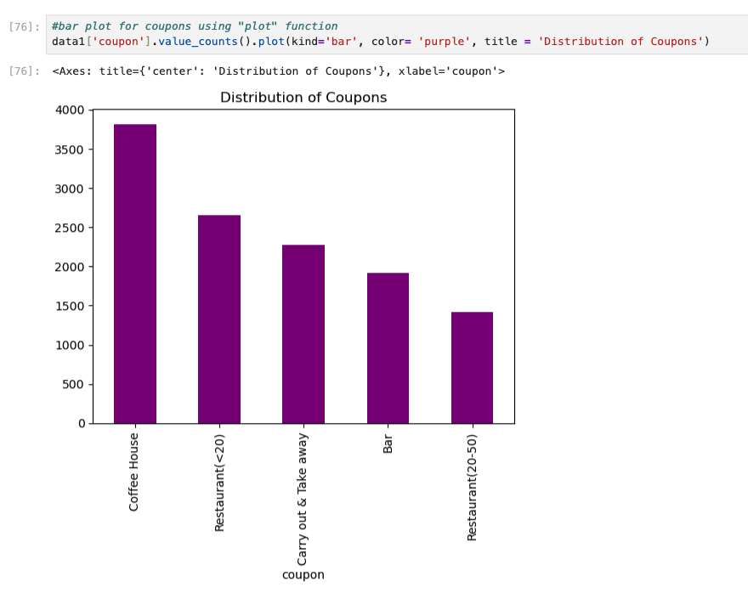

2.1 Overall Coupon Acceptance
- The overall acceptance rate of coupons is 56.93%, indicating that more than half of the drivers opted to use the coupons.
- Among different coupon types:
- Highest acceptance: Coffee House coupons
- Lowest acceptance: Restaurant coupons ($20–$50 range)
- This suggests that lower-cost or casual venues are more attractive to drivers.

2.2 Impact of Temperature
- Most coupons were accepted when the temperature ranged between 75°F and 80°F.
- This indicates that moderate weather conditions positively influence decision-making, possibly due to increased travel or leisure activity.
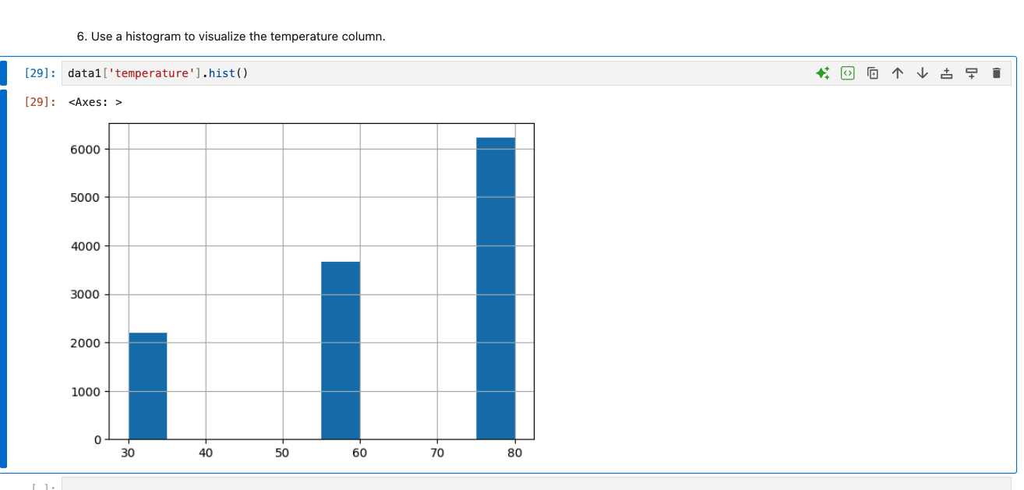

2.3 Data Quality Check
- A total of 7 duplicate entries were identified and considered during analysis.

2.4 Bar Visit Frequency vs Acceptance
- Drivers visiting bars ≤ 3 times/month:
  - Acceptance rate: 62.29%
- Drivers visiting bars > 3 times/month:
  - Acceptance rate: 18.73%
Surprisingly, frequent bar visitors are less likely to accept coupons, possibly because they do not perceive additional value.

2.5 Age and Bar Visits
Drivers who:
  - Visit bars more than once a month
  - Are over 25 years old leads to acceptance rate: 59.24%
Indicates that mature drivers with moderate bar habits are more responsive.

2.6 Combined Behavioral and Demographic Factors
Drivers who:
- Visit bars more than once a month
- Have no child passengers
- Are not in farming/fishing/forestry occupations leads to acceptance rate: 81.02%
This is the highest observed acceptance rate, indicating a strong target segment

2.7 Age-Based Comparison
- Drivers over 25 years: 59.24%
- Drivers visiting bars frequently: 18.73%
Age appears to be a stronger predictor than frequency alone.

2.8 Comparative Segment Analysis
Segment | Acceptance Rate
Bar >1/month + no kids + not widowed | 81.02%
Bar >1/month + age <30 | 41.78%
Frequent cheap restaurant visitors + income <50K | 10.12%
- Lifestyle factors outperform income-based factors in predicting acceptance.
- Moderate users (not frequent bar-goers) are more likely to accept coupons.
- Environmental conditions (temperature) influence behavior.
- Demographics (age, passengers, occupation) significantly impact decisions.
- High-value coupons (expensive restaurants) are less attractive.
- Lifestyle factors outperform income-based factors in predicting acceptance.
- Behavioral segmentation provides better insights than single-variable analysis.
Drivers who are moderately social (occasional bar visitors), over the age of 25, and not constrained by family responsibilities (e.g., no children passengers) are the most likely to accept bar coupons. Additionally, favorable environmental conditions and lower-cost options further increase acceptance rates, while frequent bar-goers and lower-income segments show reduced responsiveness.
Conclusion: Coupon acceptance is driven more by lifestyle and situational factors than by income or frequency alone.

